GENETIC CODE/ FUN FACTS REFRENCES:
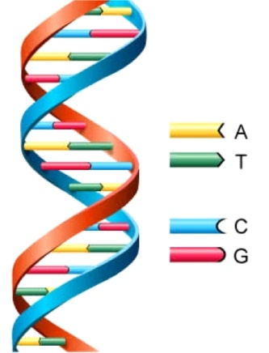
http://www.astrochem.org/sci_img/dna.jpg
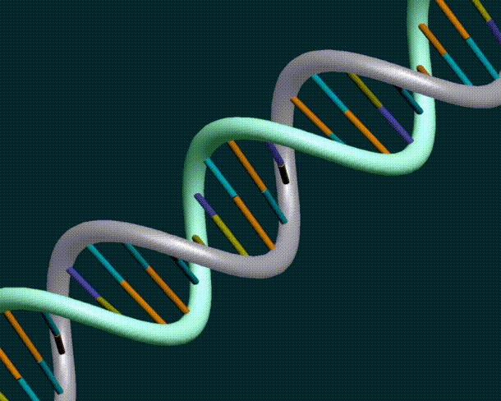
http://blogs.villagevoice.com/runninscared/2012/04/if_youre_dna_is.php

DNA Typing Facts and Above Picture:
http://www.biopoliticaltimes.org/article.php?id=5398
DNA Typing Facts:
http://www.dnaforensic.org/dna_typing/dnatyping_1.html

http://www.all-about-forensic-science.com/dna-pictures.html
DNA Fun Facts:
http://www.onlinenursingprograms.net/17-things-you-should-know-about-dna/
http://kashifk12.tripod.com/id2.html
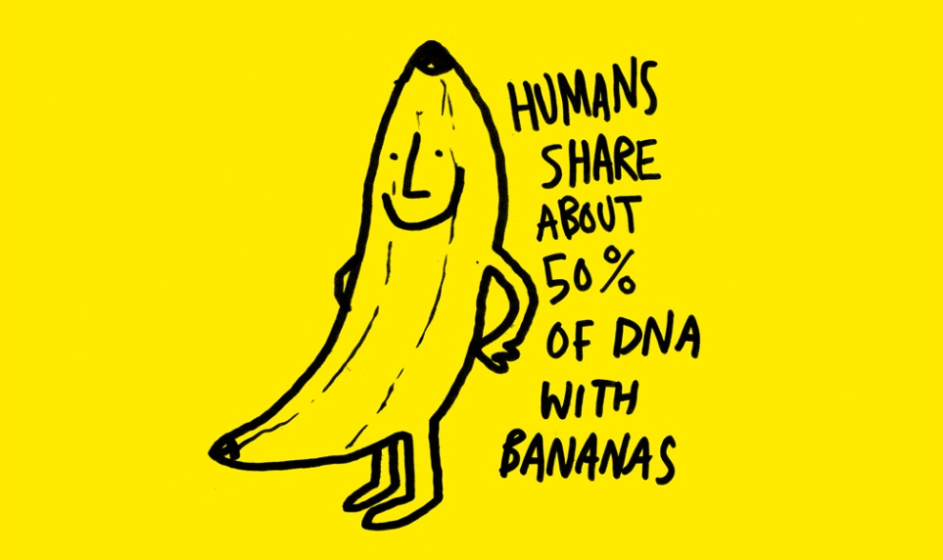
http://www.information-facts.com/women/humans-share-about-50-of-their-dna-with-bananas

